* Contains Technologies as a below;
  + Power Input: 24V AC or DC ,
  + 2 different Switching Regulator for GSM and General System Power as 4.3V and 5V,
  + Controlling GSM Power with XOR Gate and Transistor,
  + Analogue Bus Voltage Read with Buffer Op amp (Rail to Rail),
  + DAC Output,
  + Voltage levels are 24V, 15V, 5V, 4.3V,3.3V,
  + USART communication with USB Mini also contains Programming,
  + CAN Bus Communication,
  + RS485 Half Duplex Communication,,
  + SPI and I2 Communication connected to Connectors,
  + SD Memory Card communicated with SPI Interface,
  + 16x2 Character LCD Display communicated with I2C Interface,
  + FLASH Memory communicated with I2C Interface
  + Non-Isolated Signal Input,
  + Analogue Read with Linear Potentiometer,
  + Between Range of 0V to 400V DC Voltage Read with op amp,
  + Between Range of 0-10A Current Read with op amp,
  + Short Circuit Detection,
  + DC and BLDC Motor Control Driver Circuit with Back EMF Current Reading,
  + Encoder Input (Absolute and Incremental)
  + 16 Channel Isolated Input detected with Shift Register Input,
  + Accelerometer (ADXL345 IC) communicated with SPI,
  + 4 Buttons for LCD Controlling,
  + 24V Relay Output (SPDT 1 FORM C),
  + SIM800C GSM Module communicated with SPI Interface

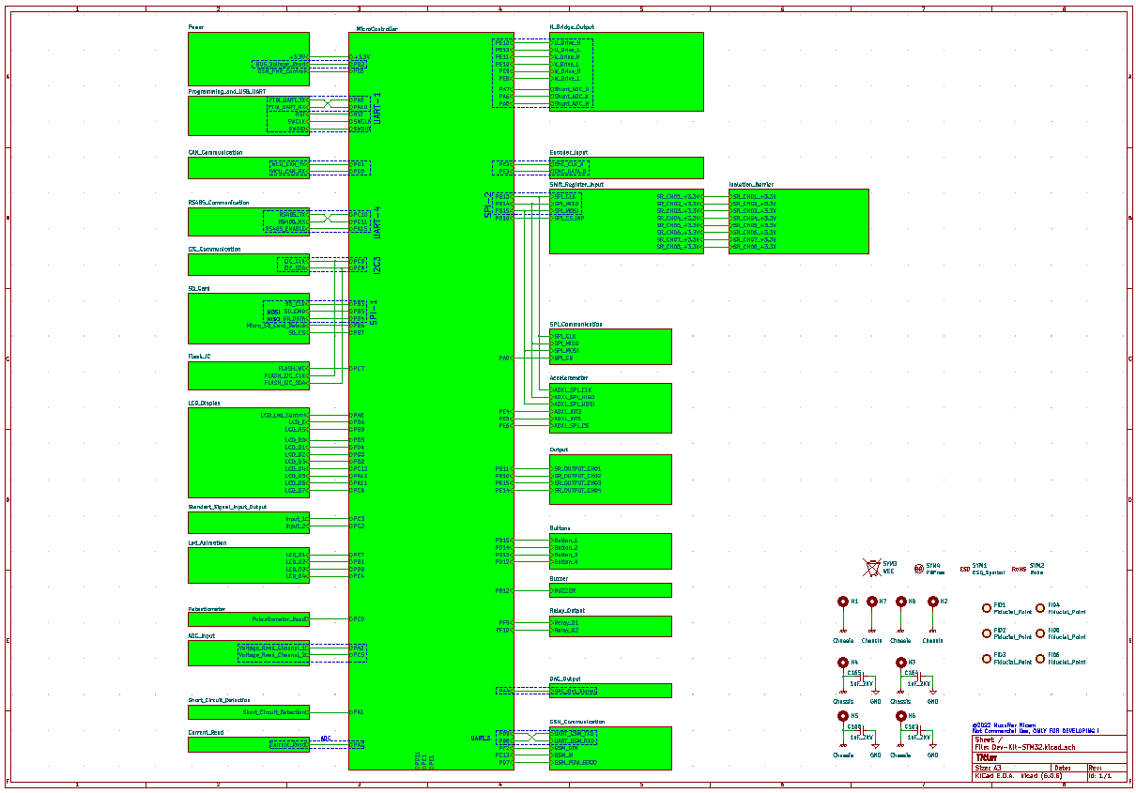

**Table 1:** Schematic Design

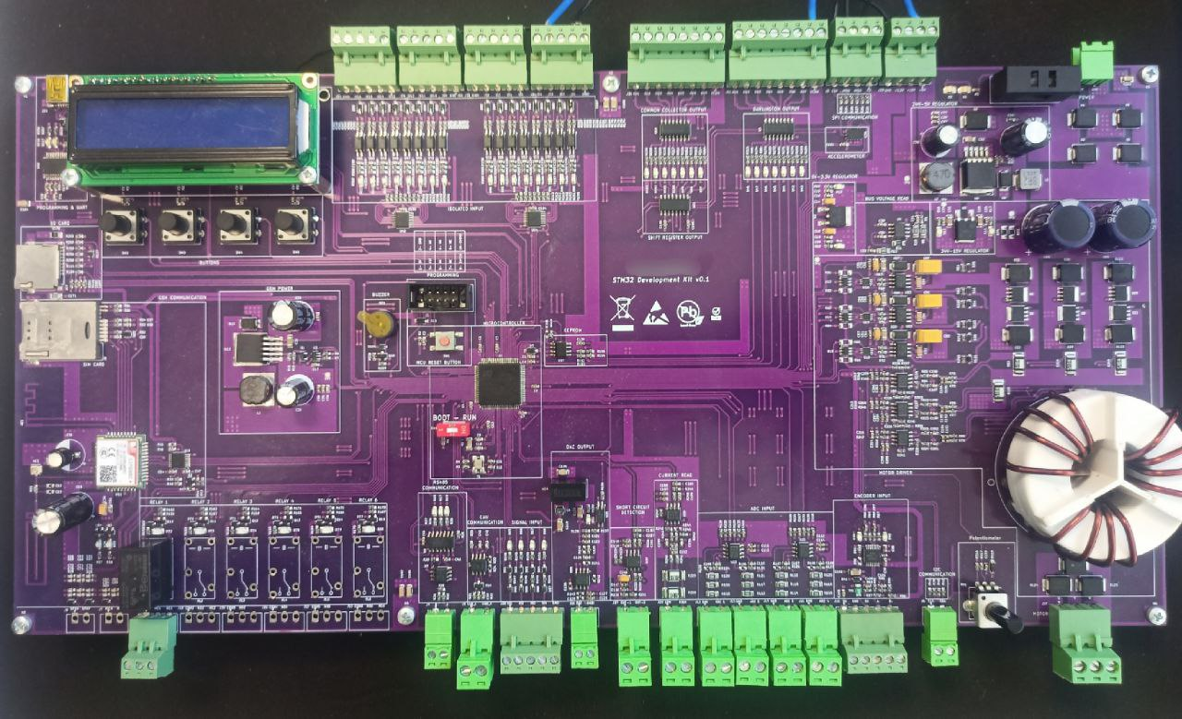

**Table 2:** STM32 MEGA Development Board

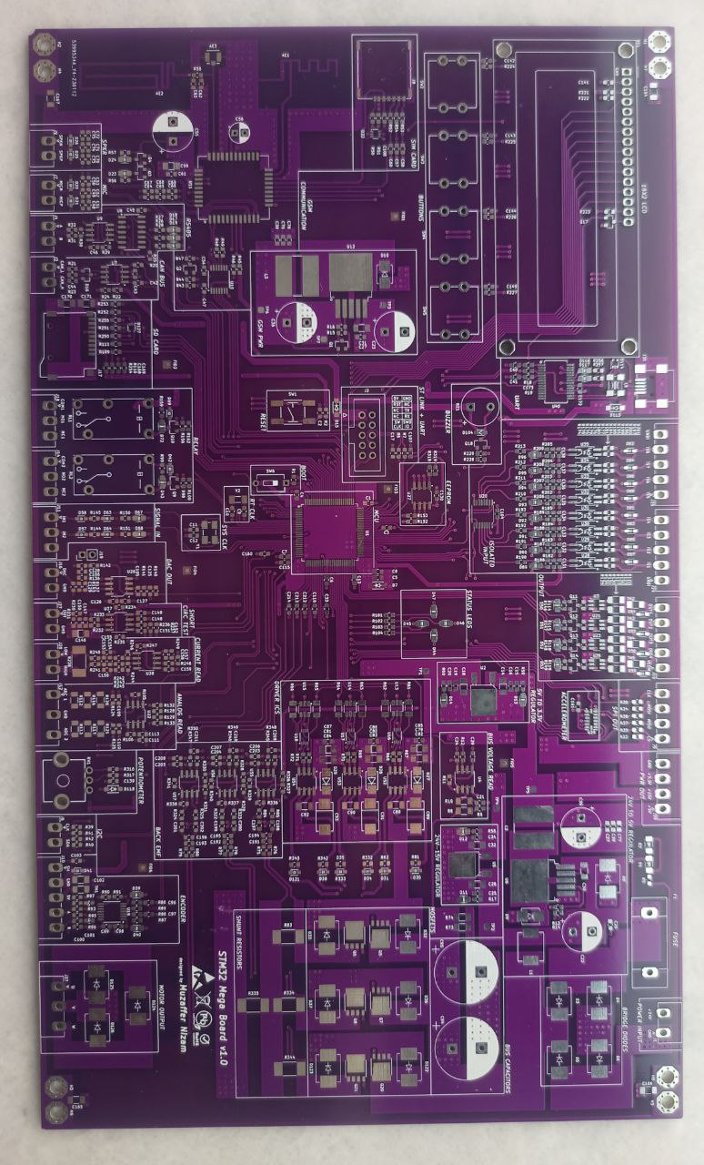

**Table 3:** STM32 MEGA Develoment Board (another version)